Father’s Day Special
Treat that special guy in your life to a relaxing day. You know he needs one with all the hard work he does.

One 90 min massage for $100.00
Normally $120.00

One 60 min massage for $80.00 with FREE hot stone add on
Normally $95.00

One 60 min massage for $80.00 with FREE foot detox
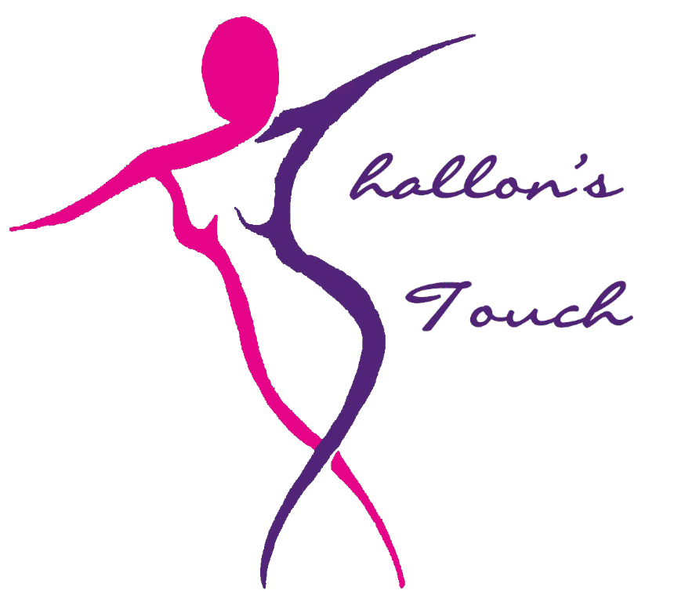
1171 East Highway 11-E
Suite 103
Talbott, TN 37877
423-737-8020

Normally $110.00

So surprise that lovely man in your life……….and
as a bonus treat yourself for every massage purchased, the one buying will receive a $10.00 credit towards their next massage for themselves.
*Not valid with any other offer or combined non-transferable. Gift Certificates are available.

